SQL Assignment- 4

1)Write a select commamnd that produces the order number,amount and date for all rows in the Orders table.

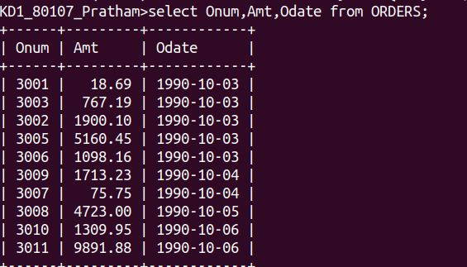

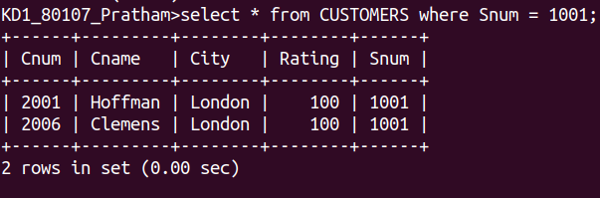
2)Write a query that produce all the rows from the customers table for which the salesperson’s number is 1001.

3) Write a query that displays the Salespeople table with the columns in the following order: City,Sname,Snum,Comm.

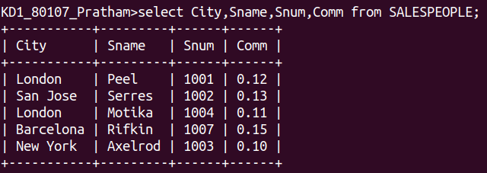

4) Write a select command that produces the rating followed by the name of each customer in San Jose.

